Class Reg Number

Candidate Name _____________________________

MERIDIAN JUNIOR COLLEGE

_________________________________________________________________________
H2 Chemistry 9647/1
Paper 1 Multiple-Choice Questions 23 September
1 hour
Additional Materials: Data Booklet and OMR answer sheet
_________________________________________________________________________

INSTRUCTIONS TO CANDIDATES
Write your name, class and register number in the spaces provided at the top of this page.
There are forty questions in this section. Answer all questions. For each question, there are four possible answers labelled A, B, C and D. Choose the one you consider correct and record your choice in soft pencil on the OMR answer sheet.
Read very carefully the instructions on the OMR answer sheet.
You are advised to fill in the OMR Answer Sheet as you go along; no additional time will be given for the transfer of answers once the examination has ended.
Use of OMR Answer Sheet
Ensure you have written your name, class register number and class on the OMR Answer Sheet.
Use a 2B pencil to shade your answers on the OMR sheet; erase any mistakes cleanly. Multiple shaded answers to a question will not be accepted.
For shading of class register number on the OMR sheet, please follow the given examples:
If your register number is 1, then shade 01 in the index number column.
If your register number is 21, then shade 21 in the index number column.

This document consists of 23 printed pages.
Section A

For each question there are four possible answers, A, B, C, and D. Choose the one you consider to be correct.

- The relative abundances of naturally-occurring isotopes of a sample of zinc are shown below.

Relative abundance
1
2
3
4
5

64 66 68 Relative isotopic mass

What is the relative atomic mass of zinc in this sample?

A 63 B 64 C 65 D 66
- Which graph correctly describes the behaviour of fixed masses of the ideal gases I and J, where I has a higher M_{r} than J?

Constant T
I
J
PV
P
P
Constant T

A B

J

I

1/V

PV
Constant P
P
Constant V

J
J

I
I

C D

T
1/T

- Which ion has more protons than neutrons, and more electrons than protons?

A He⁺ B OH⁻ C H₃O⁺ D ¹⁴CO₃⁻

- In an experiment, a sample was vaporised, ionised and passed through an electric field. Analysis of the deflection occurring at the electric region revealed the following data for the sample. It was observed that a beam of Na⁺ gives an angle of deflection of 4°.

−
Na⁺
q
α

+
Source
r

What are the possible identities of unknown particles, q and r, and the value of α ?

 | q | r | α
A | Be²⁺ | S²⁻ | 2.0
B | Ba²⁺ | S²⁻ | 1.3
C | Ba²⁺ | Br⁻ | 2.0
D | Be²⁺ | Br⁻ | 1.3

- In which pair does L have the same bond angle as M, and L is more polar than M?

 | L | M
A | H₂O | H₂S
B | N₂H₄ | N₂O₄
C | BCl₃ | BrCl₃
D | CH₂Cl₂ | SiCl₄

- Which statement describes a phenomenon which cannot be explained by hydrogen bonding?

- Ice has a lower density than water at 0°C.
- 2-nitrophenol is more volatile than 4-nitrophenol.
- Ethanoic acid has a higher melting point than expected.
- The boiling point of pentanol is higher than 2-methylbutanol.

- The rate equation for the reaction

2NO (g) + Br₂ (g) → 2NOBr (g)

is rate = k [NO]² [Br₂].

When an experiment was carried out in an excess of 3 mol dm⁻³ of NO, the concentration of Br₂ decreased to of its original value in 15 hours.
How many hours will it take for the concentration of Br₂ to decrease to of its original value if the experiment was repeated using an excess of 6 mol dm⁻³ of
NO?

A 1.25 B 3.75 C 5.00 D 7.50

- When solid lead sulfate is added to aqueous iodide, the following equilibrium is established:

PbSO₄ (s) + 2I⁻ (aq)  PbI₂ (s) + SO₄²⁻ (aq)

In an experiment, 0.0660 mol of PbSO₄ was added to 50.0 cm³ of
1.0 mol dm⁻³ of aqueous iodide solution. At equilibrium, 0.0100 mol of PbI₂ was formed.

What is the value of K_{c} for the reaction?

A 0.099 B 0.556 C 1.984 D 11.111

- The following reaction takes place using liquid ammonia as a solvent.

NaNH₂ + NH₄Cl → NaCl + 2NH₃

Which statement best explains why this reaction should be classified as a Bronsted-Lowry acid-base reaction?

- NH₃ is basic.
- NaCl is neutral.
- NH₄Cl is a salt.
- NH₂⁻ is a proton acceptor.

- The graph shows the change in pH when an aqueous base is gradually added to 25 cm³ of an acid.
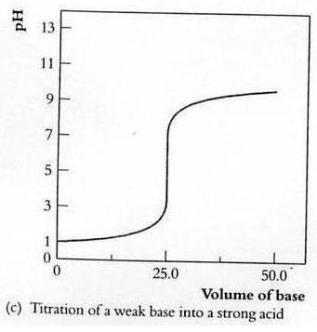

Which pair of solutions will give these results?

- 0.10 mol dm⁻³ HCl and 0.05 mol dm⁻³ NH₃
- 0.10 mol dm⁻³ HCl and 0.10 mol dm⁻³ NaOH
- 0.05 mol dm⁻³ H₂SO₄ and 0.10 mol dm⁻³ NH₃
- 0.10 mol dm⁻³ CH₃COOH and 0.10 mol dm⁻³ NaOH

- Given that the numerical values for the solubility product of Ba(BrO₃)₂ and Cs₂SiF₆ are 2.43  10⁻⁴ and 1.3  10⁻⁵ respectively.

Which of the following best describes what happens when equal volumes of 0.001 mol dm⁻³ aqueous BaSiF₆ and 0.250 mol dm⁻³ aqueous CsBrO₃ are mixed together in a test-tube?

  - No precipitation is observed.
  - Precipitation of Cs₂SiF₆ only.
  - Precipitation of Ba(BrO₃)₂ only.
  - Precipitation of both Cs₂SiF₆ and Ba(BrO₃)₂.

- Dinitrogen oxide, N=N=O, burns in ethyne in the gaseous phase to produce water vapour, carbon dioxide and nitrogen gases as the only products.

5N₂O (g) + C₂H₂ (g) → H₂O (g) + 2CO₂ (g) + 5N₂ (g)

The nitrogen-oxygen and nitrogen-nitrogen bond energies in dinitrogen oxide is 686 kJ mol⁻¹ and 418 kJ mol⁻¹ respectively.

Using appropriate information from the Data Booklet, what is the enthalpy change in kJ mol⁻¹ for the above reaction?

A −190 B −1670 C −2160 D −3342

- Which of the following can be deduced from the reduction potentials listed below?

Ag⁺ + e  Ag E^{ө} = +0.80 V
Co³⁺ + e  Co²⁺ E^{ө} = +1.82 V
Co²⁺ + 2e  Co E^{ө} = −0.28 V
Ni²⁺ + 2e  Ni E^{ө} = −0.25 V
Pb⁴⁺ + 2e  Pb²⁺ E^{ө} = +1.69 V
Pb²⁺ + 2e  Pb E^{ө} = −0.13 V

  - Ag is a better reducing agent than Pb²⁺.
  - Co³⁺ is the strongest reducing agent.
  - Ni²⁺ is a better oxidising agent than Pb²⁺.
  - Ni²⁺ can be reduced by Co²⁺.
- Silver oxide cells are used in small-scale applications such as cameras and calculators. They contain powdered zinc metal, an alkaline electrolyte and silver oxide encased by a nickel or steel container, as shown.
Powdered zinc
Ag₂O

Nickel casing

The cell reaction is:

Ag₂O (s) + Zn (s) ⎯→ 2Ag (s) + ZnO (s)

What is the equation for the reaction at the negative electrode of the cell?

- Zn (s) + 2H⁺ (aq) → Zn²⁺ (aq) + H₂ (g)
- Zn (s) + 2OH⁻ (aq) → ZnO (s) + H₂O (l) + 2e
- ZnO (s) + H₂O (l) + 2e → Zn (s) + 2OH⁻ (aq)
- Ag₂O (s) + H₂O (l) + 2e → 2Ag (s) + 2OH⁻ (aq)

- W, X, Y and Z are elements in Period 3.

W has greater electrical conductivity than Y but lower first ionisation energy than X. Y has higher boiling point than W, and Z has a greater atomic radius than W.

Based on this information, what is the correct arrangement of the elements
in increasing proton number?

- W, X, Y, Z
- X, Y, W, Z
- Y, X, Z, W
- Z, W, Y, X

- A mixture of the oxide and chloride of two elements of the third period is dissolved in water. It was found that the solution was approximately neutral.

Which pair could be the constituents of the mixture?

- SiO₂ and PCl₃
- Na₂O and MgCl₂
- MgO and Al₂Cl₆
- SO₃ and SiCl₄

- How many unpaired 3d electrons does Cr have in K₃[Cr(C₂O₄)₃].3H₂O?

A 2 B 3 C 4 D 5

- Which statement is true about the first row transition metals or its compounds?

- [Co(en)₂(CN)₂]²⁺ has a coordination number of 4.
- Fe³⁺ is more stable in acidic than in alkaline medium.
- Yellow [CrO₄]²⁻ is oxidised to orange [Cr₂O₇]²⁻ in an acidic medium.
- Fe₂(CO₃)₃ cannot be prepared by reacting FeCl₃(aq) with Na₂CO₃(aq).
- Which pair of graphs best represents the pH of 0.1 mol dm⁻³ of aqueous HX and the volatility of HX?

 | pH of 0.1 mol dm⁻³ of HX(aq) |  | Volatility of HX
A | HF  HBr  pH  HCl  HI | Volatility  HF  HCl  HBr  HI
B | pH  HF  HCl  HBr  HI | Volatility  HF  HCl  HBr  HI
C | pH  HF  HCl  HBr  HI | Volatility  HF  HCl  HBr  HI
D | pH  HF  HCl  HBr  HI | Volatility  HF  HCl  HBr  HI

- 2,2-dimethylbutane was reacted with limited chlorine in the presence of
UV light.

Assuming that only mono-chlorination takes place, what is the ratio of the products obtained?

 | 1-chloro-2,2-dimethylbutane | 3-chloro-2,2-dimethylbutane | 1-chloro-3,3-dimethylbutane
A | 3 | 3 | 3
B | 3 | 2 | 3
C | 9 | 2 | 3
D | 9 | 2 | 2

- A nitrile Q is treated with LiAlH₄ to give a compound of the formula C₂H₇N.
In a separate reaction, Q was hydrolysed in acidic medium.

What would be formed if the products from these two reactions were mixed together?

- CH₃CONHCH₂CH₃
- CH₃CH₂CONHCH₂CH₃
- (CH₃CO₂⁻)(CH₃CH₂NH₃⁺)
- (CH₃CH₂CO₂⁻)(CH₃CH₂NH₃⁺)

- Which of the following shows a correct mechanistic step in the reaction between the stated reagents?

 |  | Reagents | Step
 | A | chloropropane and  ethanolic sodium hydroxide, heat | 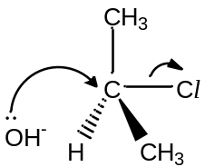
 | B | propanal and hydrogen cyanide,  trace amount of sodium hydroxide, cold | 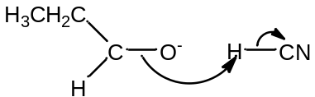
 | C | benzene and chlorine in presence of iron catalyst | 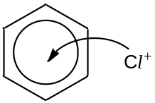
 | D | propene and bromine monochloride in tetrachloromethane | 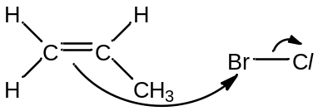

- Which method is able to separate benzene from a mixture of benzene, methylbenzene and phenol?

A shaking the mixture with aqueous Br₂
B shaking the mixture with hot ethanoic acid and concentrated H₂SO₄
C shaking the mixture with hot concentrated HNO₃ and concentrated H₂SO₄
D shaking the mixture with hot acidified KMnO₄, followed by excess dilute NaOH
- A new industrial preparation of propyl propanoate has been developed using cheap sources of propanol.

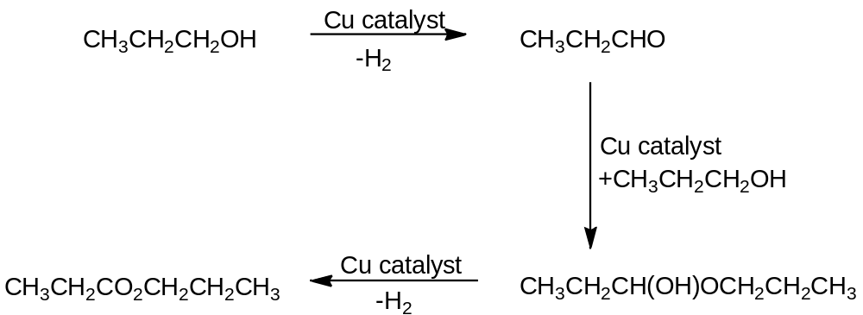
Which process is involved at some stage in this reaction sequence?

- Disproportionation
- Electrophilic Addition
- Nucleophilic Addition
- Reduction

- Pravastatin is a drug used to lower cholesterol in the blood.

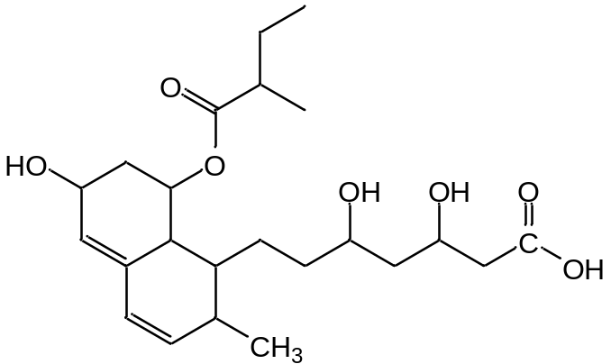
Pravastatin

Which statement about Pravastatin is likely to be correct?

- It reacts with only 3 moles of phosphorus pentachloride at room temperature and pressure.
- It reacts with only 3 moles of hydrogen gas in the presence of nickel catalyst and heat.
- It reacts with acidified potassium manganate(VII) under reflux to form one organic product.
- It reacts with liquid bromine in tetrachloromethane to form a compound with 12 chiral centres.

- Which of the following is arranged in decreasing order of solubility in water?

- sodium propanoate, propanoic acid, propanol, propanal
- sodium propanoate, propanoic acid, propanal, propanol
- propanoic acid, propanol, propanal, sodium propanoate
- propanal, propanol, propanoic acid, sodium propanoate

- What is the correct order of increasing pK_{a} for the following compounds?

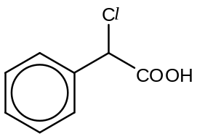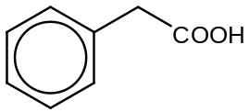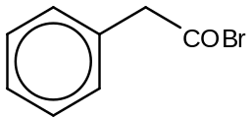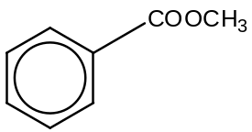
E F G H

- E, F, H, G
- G, E, F, H
- G, F, E, H
- H, F, E, G

- Deuterium, D, is an isotope of hydrogen,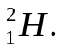

Which reaction will not yield a stable organic compound containing deuterium?

A | 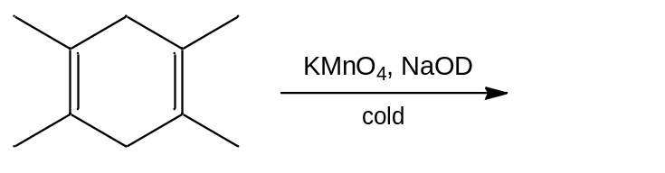
B | 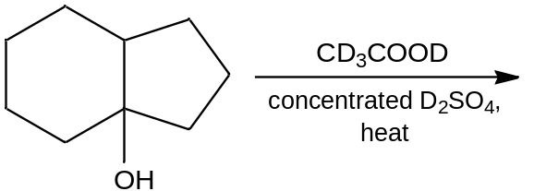
C | 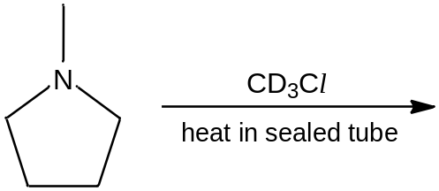
D | 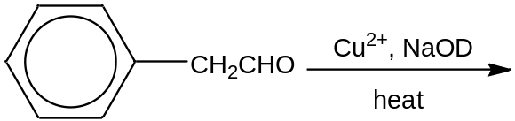

- Which reagent will give a visible observation when it is added to compound K?

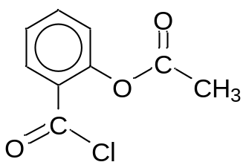

Compound K

- hot alkaline iodine
- hot hydrochloric acid
- aqueous sodium hydrogencarbonate
- hot acidified potassium dichromate(VI)

- A polypeptide was digested using two different enzymes. The fragments obtained were separated using electrophoresis. Analysis of the fragments from each digestion gave the following results:

Digestion using enzyme N:
thr-phe-leu
cys-glu-val
ser-glu-cys
asp-cys

Digestion using the enzyme O:
val-asp-cys-thr
phe-leu-ser
glu-cys
cys-glu

What is the correct sequence of the polypeptide structure?

- cys-glu-val-ser-glu-cys-asp-cys-thr-phe-leu
- cys-glu-val-asp-cys-thr-phe-leu-ser-glu-cys
- glu-cys-glu-val-asp-cys-thr-phe-leu-ser-glu
- ser-glu-cys-glu-val-asp-cys-thr-phe-leu-ser
Section B

For each of the questions in this section, one or more of the three numbered statements 1 to 3 may be correct.

Decide whether each of the statements is or is not correct (you may find it helpful to put a tick against the statements that you consider to be correct.)

The responses A to D should be selected on the basis of

A | B | C | D
1, 2 and 3  are  correct | 1 and 2  only are  correct | 2 and 3  only are  correct | 1 only  is  correct

No other combination of statements is used as a correct response.

- Iodine atoms can react with argon in the following reaction.

2I (g) + Ar (g) → ArI (g) + I (g)

The order of reaction was investigated by carrying out experiments with varying concentrations of I and Ar as shown in the table below.

Expt No | [I] / mol dm⁻³ | [Ar] / mol dm⁻³ | Initial rate / mol dm⁻³ min⁻¹
1 | 0.001 | 0.1 | 0.0874
2 | 0.002 | 0.1 | 0.348
3 | 0.004 | 0.5 | 6.96
4 | 0.006 | 1.0 | 31.3

What deductions can be made from the results?

- The rate constant has the units mol⁻² dm⁶ min⁻¹.
- The above equation is the rate-determining step.
- Doubling the volume of the reaction vessel will decrease the rate by
times.

The responses A to D should be selected on the basis of

A | B | C | D
1, 2 and 3  are  correct | 1 and 2  only are  correct | 2 and 3  only are  correct | 1 only  is  correct

No other combination of statements is used as a correct response.

- The equilibrium constant K_{c} for the decomposition reaction:

U (g)  V (g) + W (g)

is found to vary with temperature as shown in the diagram below.

K_{c}

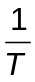

Which conclusions can be drawn from this information?

- The forward reaction is endothermic.
- The equilibrium mixture will have a higher proportion of U at higher pressures.
- The addition of a catalyst will change the shape of the graph above.

- Which statements are true for the electrochemical cell below?
High-resistance voltmeter
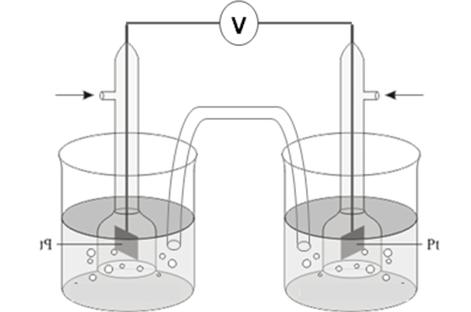

H₂(g)
1 atm, 298K
  - mol dm⁻³
HCl (aq)
Pt
H₂ (g)
1 atm, 298K
Pt
1.0 mol dm⁻³
HCl (aq)
  - mol dm⁻³
HCl (aq)
Salt bridge
Pt
H₂ (g)
1 atm, 298K

- Electrons flow from the left to the right.
- The E_{cell} value decreases when NH₃ (aq) is added to the half-cell on the right.
- The E_{cell} value remains the same when AgNO₃ (aq) is added to the half-cell on the left.

- Consider the following enthalpy changes:

½ Cl₂ (g) → Cl (g) ∆H₁
½ Cl₂ (g) + e → Cl⁻ (g) ∆H₂
½ Cl₂ (g) + e → Cl⁻ (aq) ∆H₃

Which statements are true?

- ∆H₁ is equal to ½ B.E.(Cl–Cl).
- The 1st electron affinity of chlorine is ∆H₂−∆H₁.
- The enthalpy change of hydration of chloride is ∆H₃.

The responses A to D should be selected on the basis of

A | B | C | D
1, 2 and 3  are  correct | 1 and 2  only are  correct | 2 and 3  only are  correct | 1 only  is  correct

No other combination of statements is used as a correct response.

- Which properties decrease with increasing atomic number for Group II elements (magnesium to barium) and their compounds?

- The pH of the oxides.
- The electronegativity of the element.
- The magnitude of the lattice energy of Group II oxides.

- Hydrogen chloride gas is prepared by adding concentrated sulfuric acid to solid sodium chloride. The same method was used to prepare hydrogen iodide but the yield is very low when concentrated sulfuric acid is added to solid sodium iodide.

Which deductions can be made from the above?

- Iodide is a stronger reducing agent than chloride.
- Concentrated sulfuric acid is a weaker oxidising agent than hydrogen chloride.
- The reactions between the sodium halides and concentrated sulfuric acid are redox reactions.

- For the following reaction:

(CH₃)₃CSO₂Cl + CH₃CH₂OH → (CH₃)₃CSO₃CH₂CH₃ + HCl

Which statements are likely to be true?

- The C−O bond is not broken.
- Cl⁻ is displaced by CH₃CH₂O⁻.
- The reaction involves a nucleophile.

- The Grignard reaction is a very important tool in organic reactions involving the formation of carbon-carbon bond. Grignard reagents are formed by reacting halogenoalkane, R-X, with magnesium in dry ether.

For example, reaction of CH₃Cl with Mg,
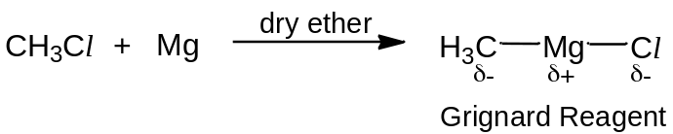
Grignard reagents allow the carbon chain of carbonyl compounds to be lengthened.

For example,
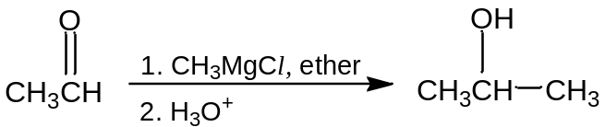

Which compounds could be made from a ketone and a Grignard reagent?

- CH₃C(CH₂CH₃)₂OH
- CH₃CH₂CH₂CH₂OH
- (CH₃CH₂)₂CHOH
The responses A to D should be selected on the basis of

A | B | C | D
1, 2 and 3  are  correct | 1 and 2  only are  correct | 2 and 3  only are  correct | 1 only  is  correct

No other combination of statements is used as a correct response.

- Salicylic acid is an important compound in its medicinal and cosmetic uses.

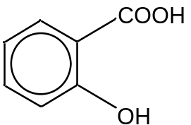

Salicylic acid

Which compounds give salicylic acid on acid hydrolysis?

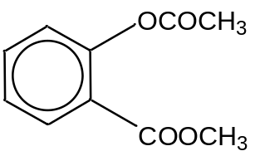
1

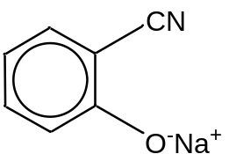
2

3
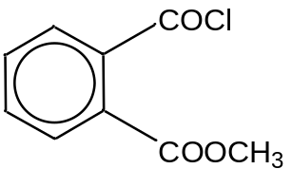

- α-aminobutyric acid and γ-aminobutyric acid are isomers.

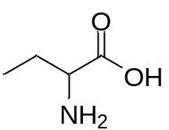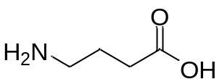

α-aminobutyric acid γ-aminobutyric acid

Which statements are true?

- Both are soluble in water.
- Both can form zwitterions.
- Both can be obtained from the hydrolysis of protein.

END OF PAPER

